**DAY 7 – CLASS EXERCISES**

**CLASS EXERCISE 1**

**package** com.softwaretest1.demo1;

**import** org.openqa.selenium.WebDriver;

**import** org.openqa.selenium.chrome.ChromeDriver;

**import** org.openqa.selenium.chrome.ChromeOptions;

**import** org.testng.Assert;

**import** org.testng.annotations.Test;

**import** io.github.bonigarcia.wdm.WebDriverManager;

**public** **class** Day7_CE1 {

@Test

**public** **void** titleCheck() {

WebDriverManager.*chromedriver*().setup ();

ChromeOptions co=**new** ChromeOptions();

co.addArguments ("--remote-allow-origins=*");

WebDriver driver=**new** ChromeDriver(co);

driver.get("https://demo.wpeverest.com/user-registration/guest-registration-form/");

driver.manage().window().maximize();

String actual=driver.getTitle();

String expected="Guest Registration Form – User Registration";

Assert.*assertEquals*(actual,expected);

}

}

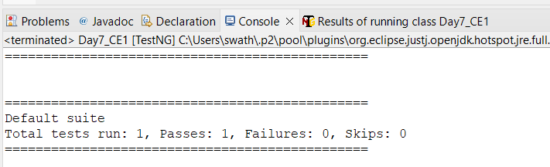

**CLASS EXERCISE – 2**

**package** com.softwaretest1.demo1;

**import** org.testng.Assert;

**import** org.testng.annotations.Test;

**public** **class** Calculator {

@Test(priority=1)

**public** **void** add() {

**int** a=5;

**int** b=10;

**int** actual=a+b;

**int** exp=15;

Assert.*assertEquals*(actual, exp);

}

@Test(priority=2)

**public** **void** subt() {

**int** a=25;

**int** b=10;

**int** actual=a-b;

**int** exp=15;

Assert.*assertEquals*(actual, exp);

}

@Test(priority=3)

**public** **void** mult() {

**int** a=5;

**int** b=3;

**int** actual=a*b;

**int** exp=15;

Assert.*assertEquals*(actual, exp);

}

@Test(priority=4)

**public** **void** div() {

**int** a=20;

**int** b=10;

**int** actual=a/b;

**int** exp=2;

Assert.*assertEquals*(actual, exp);

}

}

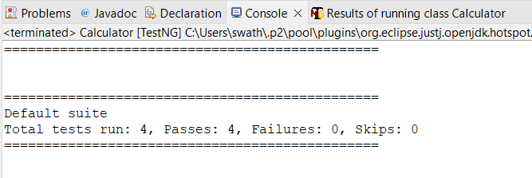

**CLASS EXERCISE – 3**

**package** com.softwaretest1.demo1;

**import** org.testng.annotations.Test;

**import** io.github.bonigarcia.wdm.WebDriverManager;

**import** org.testng.annotations.BeforeMethod;

**import** org.openqa.selenium.By;

**import** org.openqa.selenium.WebDriver;

**import** org.openqa.selenium.chrome.ChromeDriver;

**import** org.openqa.selenium.chrome.ChromeOptions;

**import** org.testng.annotations.AfterMethod;

**public** **class** Day7_CE3 {

WebDriver driver;

@Test

**public** **void** Login() **throws** InterruptedException {

Thread.*sleep*(5000);

driver.findElement(By.*xpath*("//input[@name=\"username\"]")).sendKeys("Admin");

driver.findElement(By.*xpath*("//input[@name=\"password\"]")).sendKeys("admin123");

driver.findElement(By.*xpath*("//*[@id=\"app\"]/div[1]/div/div[1]/div/div[2]/div[2]/form/div[3]/button")).click();

}

@BeforeMethod

**public** **void** beforeMethod() {

ChromeOptions co = **new** ChromeOptions();

co.addArguments("--remote-allow-origins=*");

WebDriverManager.*chromedriver*().setup();

driver = **new** ChromeDriver(co);

driver.get("https://opensource-demo.orangehrmlive.com/web/index.php/auth/login");

driver.manage().window().maximize();

}

@AfterMethod

**public** **void** afterMethod() {

driver.close();

}

}

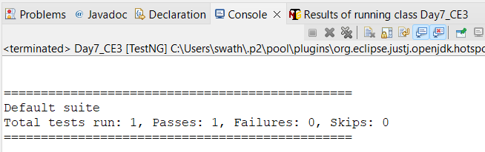

**CLASS EXERCISE – 4**

**package** com.softwaretest1.demo1;

**import** org.openqa.selenium.By;

**import** org.openqa.selenium.WebDriver;

**import** org.openqa.selenium.chrome.ChromeDriver;

**import** org.openqa.selenium.chrome.ChromeOptions;

**import** org.testng.Assert;

**import** org.testng.annotations.AfterClass;

**import** org.testng.annotations.BeforeClass;

**import** org.testng.annotations.Test;

**import** io.github.bonigarcia.wdm.WebDriverManager;

**public** **class** Day7_CE4 {

WebDriver driver;

@Test

**public** **void** Login() **throws** InterruptedException {

Thread.*sleep*(5000);

driver.findElement(By.*xpath*("//input[@name=\"username\"]")).sendKeys("Admin");

driver.findElement(By.*xpath*("//input[@name=\"password\"]")).sendKeys("admin123");

driver.findElement(By.*xpath*("//*[@id=\"app\"]/div[1]/div/div[1]/div/div[2]/div[2]/form/div[3]/button")).click();

String actualUrl = driver.getCurrentUrl();

String expectedUrl = "https://opensource-demo.orangehrmlive.com/web/index.php/dashboard/index";

Assert.*assertEquals*(actualUrl, expectedUrl);

}

@Test (dependsOnMethods = "Login")

**public** **void** Logout() **throws** InterruptedException {

Thread.*sleep*(5000);

driver.findElement(By.*xpath*("//*[@id=\"app\"]/div[1]/div[1]/header/div[1]/div[2]/ul/li/span")).click();

driver.findElement(By.*xpath*("//*[@id=\"app\"]/div[1]/div[1]/header/div[1]/div[2]/ul/li/ul/li[4]/a")).click();

}

@BeforeClass

**public** **void** beforeMethod() {

ChromeOptions co = **new** ChromeOptions();

co.addArguments("--remote-allow-origins=*");

WebDriverManager.*chromedriver*().setup();

driver = **new** ChromeDriver(co);

driver.get("https://opensource-demo.orangehrmlive.com/web/index.php/auth/login");

driver.manage().window().maximize();

}

@AfterClass

**public** **void** afterMethod() {

driver.close();

}

}

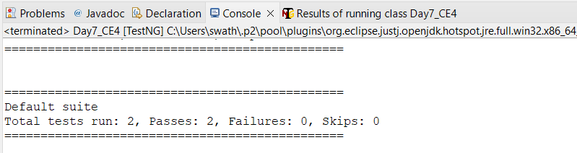

**CLASS EXERCISE – 5**

**package** com.softwaretest1.demo1;

**import** org.testng.annotations.Test;

**import** io.github.bonigarcia.wdm.WebDriverManager;

**import** org.testng.annotations.BeforeMethod;

**import** java.util.concurrent.TimeUnit;

**import** org.openqa.selenium.By;

**import** org.openqa.selenium.WebDriver;

**import** org.openqa.selenium.chrome.ChromeDriver;

**import** org.openqa.selenium.chrome.ChromeOptions;

**import** org.testng.Assert;

**import** org.testng.annotations.AfterMethod;

**public** **class** Day7_CE5_01 {

WebDriver driver;

@Test(groups= {"SmokeTest"})

**public** **void** url() {

String actualUrl = driver.getCurrentUrl();

String expectedUrl = "https://www.godaddy.com/en-in";

Assert.*assertEquals*(actualUrl, expectedUrl);

String actualTitle = driver.getTitle();

String expectedTitle = "Domain Names, Websites, Hosting & Online Marketing Tools - GoDaddy IN";

Assert.*assertEquals*(actualTitle, expectedTitle);

}

@Test(groups= {"RegressionTest"})

**public** **void** test2() {

driver.manage().timeouts().~~implicitlyWait~~(10,TimeUnit.***SECONDS***);

driver.findElement(By.*xpath*("//*[@id=\"id-631b049a-e9c0-4d24-8710-c504745206dd\"]/div[2]/div[1]/ul/li[1]/button")).click();

driver.findElement(By.*xpath*("//*[@id=\"id-631b049a-e9c0-4d24-8710-c504745206dd\"]/div[2]/div[1]/ul/li[1]/div/div[2]/div[1]/ul/li[2]/a")).click();

}

@Test(groups= {"RegressionTest"})

**public** **void** test3() {

driver.manage().timeouts().~~implicitlyWait~~(10,TimeUnit.***SECONDS***);

driver.findElement(By.*xpath*("//*[@id=\"id-631b049a-e9c0-4d24-8710-c504745206dd\"]/div[2]/div[1]/ul/li[1]/button")).click();

driver.findElement(By.*xpath*("//*[@id=\"id-631b049a-e9c0-4d24-8710-c504745206dd\"]/div[2]/div[1]/ul/li[1]/div/div[2]/div[1]/ul/li[2]/a")).click();

String aTitle=driver.getTitle();

System.***out***.print(aTitle);

}

@BeforeMethod

**public** **void** beforeMethod() {

ChromeOptions co = **new** ChromeOptions();

co.addArguments("--remote-allow-origins=*");

WebDriverManager.*chromedriver*().setup();

driver = **new** ChromeDriver(co);

driver.get("https://www.godaddy.com/en-in");

driver.manage().window().maximize();

}

@AfterMethod

**public** **void** afterMethod() {

driver.close();

}

}

**testng.xml**

<?xml version="1.0" encoding="UTF-8"?>

<!DOCTYPE suite SYSTEM "https://testng.org/testng-1.0.dtd">

<suite name="Suite">

<test thread-count="5" name="Test">

<groups>

<run>

<include name="SmokeTest"></include>

<exclude name="RegressionTest"></exclude>

</run>

</groups>

<classes>

<class name="com.softwaretest1.demo1.Day6"/>

<class name="com.softwaretest1.demo1.AppTest"/>

</classes>

</test> <!-- Test -->

</suite> <!-- Suite -->